Experiment 2: Decision Tree Classifier (scikit-learn)
ED408 — Statistical / Supervised Machine Learning Lab
Aim: Build a Decision Tree classifier using scikit-learn and visualize the learned tree structure.
Dataset Used: BSDS500 (Berkeley Segmentation Data Set) ships as natural images with hand-annotated object-boundary ground truth, not a tabular dataset. It was converted into a tabular binary-classification dataset (data/bsds_features.csv, built by scripts/build_dataset.py): one row per sampled pixel from all 200 BSDS500 training images, 10 features (R, G, B, gray, grad_mag, grad_dir, laplacian, local_std, x_norm, y_norm) capturing colour, gradient, texture and position, and label is_edge (1 if a majority of 6 human annotators marked the pixel as a segment boundary, else 0). 24,000 rows total, perfectly balanced (12,000 / 12,000). This same dataset is reused, unchanged, for every question in this lab.
Theory
A Decision Tree recursively partitions the feature space by choosing, at each node, the feature and threshold that most reduces impurity (Gini index by default in scikit-learn). Leaves are assigned the majority class of the training samples that reach them. Trees are easy to interpret and visualize but can overfit if grown too deep, hence max_depth / min_samples_leaf are used here as regularizers.
Code
"""
Q2 — Decision Tree classifier using scikit-learn, with tree visualization,
on the BSDS500-derived edge-pixel dataset.
"""
import matplotlib.pyplot as plt
from sklearn.tree import DecisionTreeClassifier, plot_tree
from sklearn.metrics import accuracy_score, confusion_matrix, classification_report

from common import load_split, save_metrics, FIG_DIR, FEATURE_COLS

def main():
# Decision trees don't need feature scaling; keep raw feature values.
X_train, X_test, y_train, y_test = load_split(scale=False)
print(f"train={X_train.shape}, test={X_test.shape}")

clf = DecisionTreeClassifier(max_depth=6, min_samples_leaf=20, random_state=42)
clf.fit(X_train, y_train)

preds = clf.predict(X_test)
acc = accuracy_score(y_test, preds)
cm = confusion_matrix(y_test, preds)
report = classification_report(y_test, preds, target_names=["non-edge", "edge"])
print(f"Test accuracy: {acc:.4f}")
print(report)

# feature importances
importances = sorted(zip(FEATURE_COLS, clf.feature_importances_),
key=lambda t: -t[1])
print("Feature importances:")
for name, imp in importances:
print(f" {name:12s} {imp:.4f}")

fig, ax = plt.subplots(figsize=(6, 4))
names, vals = zip(*importances)
ax.barh(names, vals, color="#4C72B0")
ax.invert_yaxis()
ax.set_xlabel("importance")
ax.set_title("Decision Tree feature importances")
plt.tight_layout()
plt.savefig(FIG_DIR / "q2_tree_feature_importance.png", bbox_inches="tight")
plt.close()

# full-tree visualization
fig, ax = plt.subplots(figsize=(26, 12))
plot_tree(clf, feature_names=FEATURE_COLS, class_names=["non-edge", "edge"],
filled=True, rounded=True, fontsize=7, ax=ax)
ax.set_title(f"Decision Tree (max_depth=6) test accuracy={acc:.3f}")
plt.savefig(FIG_DIR / "q2_tree_full.png", bbox_inches="tight", dpi=150)
plt.close()

# shallow tree for a readable diagram
clf_shallow = DecisionTreeClassifier(max_depth=3, min_samples_leaf=20, random_state=42)
clf_shallow.fit(X_train, y_train)
preds_shallow = clf_shallow.predict(X_test)
acc_shallow = accuracy_score(y_test, preds_shallow)

fig, ax = plt.subplots(figsize=(16, 8))
plot_tree(clf_shallow, feature_names=FEATURE_COLS, class_names=["non-edge", "edge"],
filled=True, rounded=True, fontsize=10, ax=ax)
ax.set_title(f"Decision Tree (max_depth=3, readable) test accuracy={acc_shallow:.3f}")
plt.savefig(FIG_DIR / "q2_tree_shallow.png", bbox_inches="tight", dpi=150)
plt.close()

save_metrics("q2_decision_tree", {
"depth6_test_accuracy": acc,
"depth3_test_accuracy": acc_shallow,
"confusion_matrix": cm.tolist(),
"classification_report": report,
"feature_importances": {n: float(v) for n, v in importances},
})

if __name__ == "__main__":
main()
Output
Metric | Value
Test accuracy (depth=6) | 0.7531
Test accuracy (depth=3) | 0.7356
Top feature | local_std (importance=0.885)

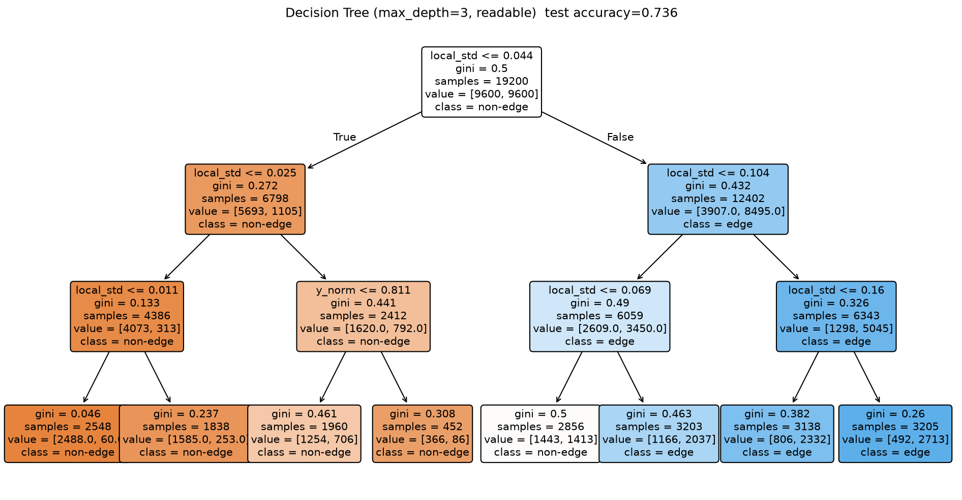
Visualized Decision Tree (max_depth=3, readable).
Result
The depth-6 tree reached 75.31% test accuracy. local_std (local texture energy) dominates the splits, confirming texture is the strongest edge indicator in this feature set.

